# User Guide

# Installation

Double click ‘mysetup.exe’, then click ‘next’ all the way till finished.

# Overview

After installation and opening the User interface, you will see the interface below.

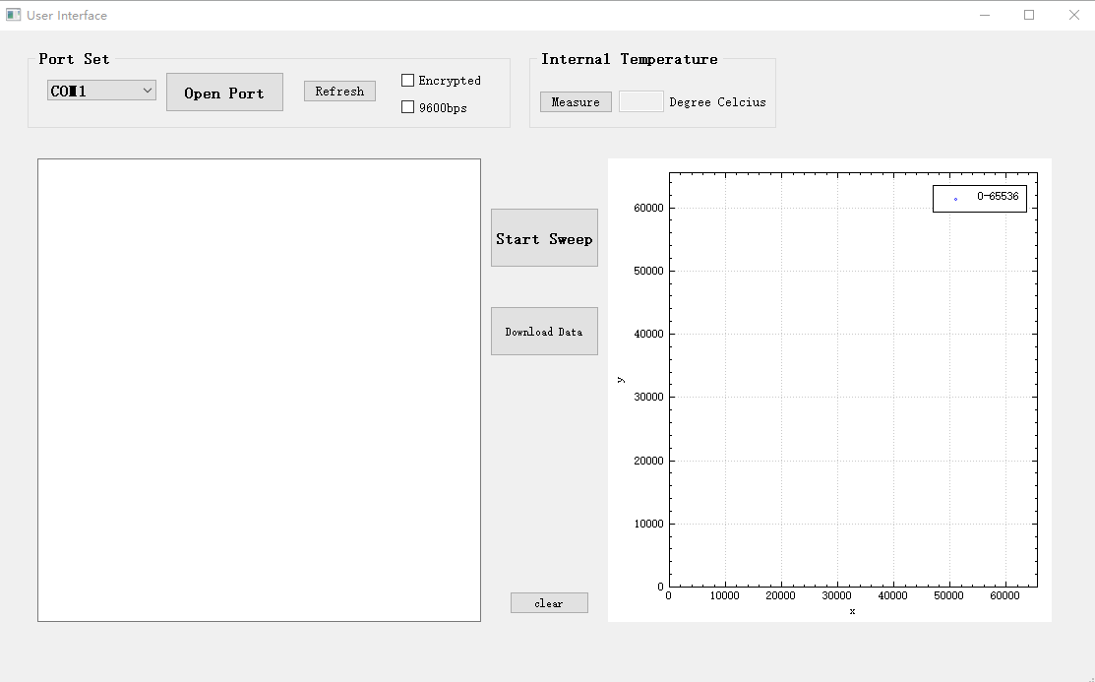

# Operation

**1. Port set**



As shown above, selecting the right com in the left combo box, then pressing ‘Open Port’ in the right button.

**2. Internal Temperature**

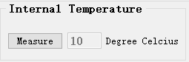

After port set, we can measure the internal temperature of chip by pressing ‘Measure’. This step can be used to test communication and monitor the state of the chip.

**3.Start Sweep**

When communication is ok, we then press start sweep. After a while, the sweeping results will be shown in both text and plot blocks. As an example, the result is shown below.

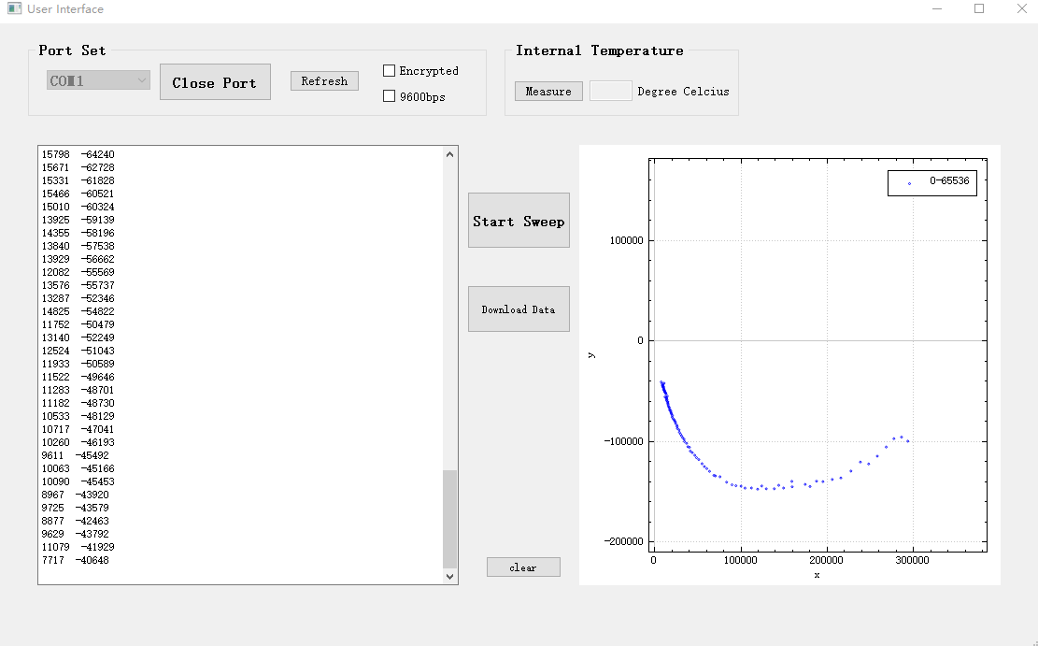

**4. Download Data**

After showing and plotting the received sweeping result, we can download it by pressing Download Data. The path and filename can be edited after pressing this button as shown below.

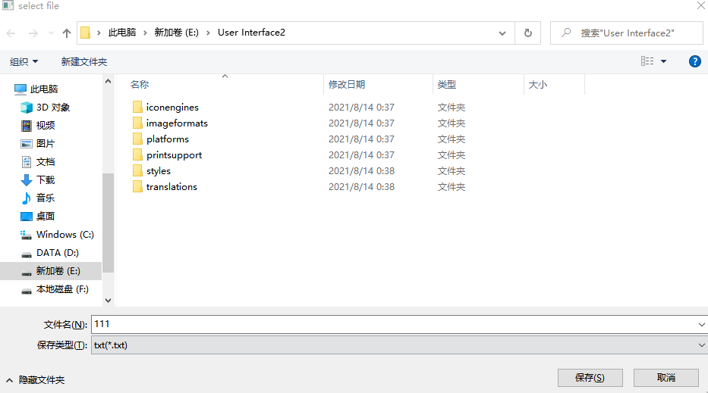

**5. clear**

After pressing clear, the content in both text and plot blocks will be cleared.